Juletrefest for Barn
Children’s Christmas Party
Saturday December 10, 2022 1:00-3:00 PM
Scandinavian Cultural Center
206 Waltham St West Newton, MA
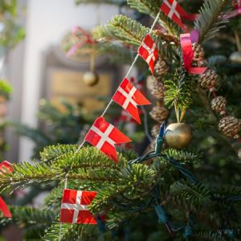

Julenisse - Storytelling - Crafts - Refreshments - Singing
Adult Admission: $2.00 Children: Free
Bring a gift with the child’s name on it for each child you bring
Information: cultural@norumbegasofn.org
Sponsored by
Norumbega Lodge #3-506, Sons of Norway
www.norumbegasofn.org

