Juletrefest
Sons of Norway Christmas Party
Friday, December 2, 2022 – 7:30 p.m.

SCANDINAVIAN CULTURAL CENTER
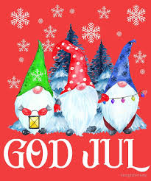
206 Waltham Street, West Newton, MA
julenisse - refreshments – singing

If you want to participate in the gift exchange,
Bring a gift worth no more than $10

Information: cultural@norumbegasofn.org

Sponsored by
Norumbega Lodge #3-506, Sons of Norway
www.norumbegasofn.org

